**Event Safety Plan and Risk Assessment**

**Section 1: Safety Plan**

The Safety plan **must** be completed by the Event organiser during the ‘planning’ phase to outline the safety management arrangements for the event and provide House Staff and Third parties with key information they require.

|  |  |  |  |  |
| --- | --- | --- | --- | --- |
| **Event Overview** | | | | |
| **Event name:** | Click here to enter text. | | | |
| **Organisation name:** | Click here to enter text. | | **Event number** | Click here to enter text. |
| **Name of the event organiser:** | Click here to enter text. | | **Email** | Click here to enter text. |
| **Contact number** | Click here to enter text. |
| **Scheduling:**  *Specify the start/finish time and date of each phase* | **Event ‘setup’ date/time** | Click here to enter text. | **Finish date/time** | Click here to enter text. |
| **Event ‘delivery’ date/time** | Click here to enter text. | **Finish date/time** | Click here to enter text. |
| **Event ‘break’ date/time** | Click here to enter text. | **Finish date/time** | Click here to enter text. |
| **Summary of the event:**  *Outline what the event delivery entails, including the expected number of guests; profile of the guests; activities being undertaken, etc* | Click here to enter text. | | | |
| **Event location:**  *Where is the event taking place?* | Click here to enter text. | | | |
| **Third parties:**  *List the details of all external companies/people working on the event and tick what phase they are involved in*  *Each third party needs to complete the ‘Safety Questionnaire’*  *For additional third parties, add their details into the ‘Miscellaneous info’ box* | **Company name and primary contact** | Click here to enter text. | **Contact number** | Click here to enter text. |
| **Phase** |  |
| **Company name and primary contact** | Click here to enter text. | **Contact number** | Click here to enter text. |
| **Phase** |  |
| **Other Teams or Departments:**  *List all parliamentary teams or departments involved in ay phase of this event and the name/extension number of the primary contact* | House of Commons Catering Services, 020 7219 3090 – hoceventsteam@parliament.uk | | | |
| **Access arrangements:**  *Specify how people will access the event/estate and if there are any specific accessibility and/or escorting requirements?* | **Third parties** | All commercial deliveries and vehicles destined for the Parliamentary Estate must undergo stringent security checks at Parliament's Offsite Screening and Consolidation Centre (OSCC). Those vehicles will be security screened and allocated a tracking device and a secure monitored route to follow to the Parliamentary Estate. All deliveries must be pre-booked through the HoC Event Coordinator. All individuals reporting to the OSCC with the intention of travelling to the estate must present photo ID on arrival at the OSCC, and both drivers and passengers will be subject to passive screening by an explosive detection dog. | | |
| **Event guests** | All event attendees will access the Parliamentary Estate through a pedestrian security search point. An official invitation (electronic or hard copy) is required upon request of presentation by UK Parliament Security. Once on the estate Visitor Assistants are on hand to direct guests through to events venues. People with accessibility needs can be routed through alternative routes. Prior notice of specific accessibility needs, whilst not absolutely necessary, will help for a smoother access and egress experience. | | |
| **Welfare facilities:**  *Specify the location of toilets and hand wash facilities* | Toilet facilities, including accessible toilets, with handwash facilities are located along the visitor route off Westminster Hall, in Lower Waiting Hall and on the Lower Centre Curtain Corridor. Visitor assistants, security officers and catering staff are on hand to give directions if requested. | | | |
| **First aid arrangements:**  *Specify the location, contact details and type of first aid provision* | There are enough trained first aiders available across the Parliamentary Estate to assist should the need arise. For critical or life-threatening situations call 020 7219 3333 for an ambulance. For immediate assistance for injury or illness call 020 7219 5311 for security control or to find a first aider. Call a first aider directly in the Palace of Westminster on 020 7219 7837 or in Portcullis House on 020 7219 7835. First aid boxes are available in the main kitchen on the Principal Floor and the Banqueting kitchen on the lower floor. A duty nurse is also available in Lower Waiting Hall during office hours, Monday to Friday, for non-urgent treatment or advice. | | | |
| **Emergency arrangements:**  *Specify any special emergency procedures for Fire (including PEEP plans for guests with mobility impairments) or Security* | Different arrangements to warn of fire exist for different buildings on the Parliamentary Estate; either a series of taped messages or sounders are broadcast to raise the alarm. The policy for evacuation from all buildings across the Parliamentary Estate following a fire alarm is dispersal. On the sounding of the evacuation signal, occupants should leave the premises and move away from the building to any suitable safe location - an unaffected Parliamentary building or an open space of their choice, for example. Those evacuated can find out whether it is safe to return to the building by: calling the emergency information telephone number 0800 917 8919; a message put up on the annunciator system (should they have moved to an unaffected area of the Parliamentary Estate); occupants without access to a telephone or annunciator should contact security officers at the entrances to buildings on the Estate to establish whether the all clear has been given. Personal Emergency Evacuation Plans (PEEP) for people with mobility issues attending the event should be discussed and agreed with the event coordinator prior to the event taking place detailing specific physical needs. | | | |
| **Miscellaneous information:**  *Document any other significant safety related information or use for additional space to list third parties* | Click here to enter text. | | | |
| **Management of Significant Risks** | | | | |
| **Significant risks:**  *From the Event Risk Assessment, list any high-risk activities (including those associated with the event phases)* | **‘Build’** | Click here to enter text. | | |
| **‘Delivery’** | Click here to enter text. | | |
| **‘Break’** | Click here to enter text. | | |
| **Structures:**  *List any structures being constructed for the event* | Click here to enter text. | | | |
| **Co-ordination of work activities:**  *Where 2 or more groups of third-party workers will be sharing the same workspace, explain how their activities will be coordinated/de-conflicted* | Click here to enter text. | | | |
| **Monitoring:**  *Specify arrangements throughout the event for monitoring the management of significant risk* | **‘Build’** | Click here to enter text. | | |
| **‘Delivery’** | Click here to enter text. | | |
| **‘Break’** | Click here to enter text. | | |

**Section 2: Risk Assessment**

The Risk Assessment **must** be completed by the Event Organiser during the ‘planning’ phase to document the hazards across all phases of the Event and outline how they will be controlled.

Catering Services have started off the risk assessment for you by including some common Event hazards to illustrate what is expected. Look at how this might apply to your event, continue by identifying the hazards and documenting how you will control the risk. For reference, the Risk impact/Likelihood scales and Risk Matrix are in the appendix on the last page.

| **What are the hazards?**  **What are the risks?**  *What can cause people real harm; how could this happen?* | **Who might be harmed and how?**  *List the people who could be harmed?* | **Existing Control Measures**  *What are you already doing to reduce the likelihood and impact of potential harm?* | **Risk with existing control measures** | **Further Control Measures**  **Recommended**  *What additional actions/measures are needed to control the risk?* | **Risk after further control measures implemented** |
| --- | --- | --- | --- | --- | --- |
|
| **Access/Egress**  The Parliamentary Estate has many different entrances to each building, comprising large, heavy doors, revolving doors, pods etc.  A few accidents each year are reported involving staff and visitors who have trapped fingers, arms, and bumped heads etc. Most of these injuries result in minor cuts and bruising etc. | * **Visitors** * **Members** * **Third parties** * **House staff** | * All entry and exit building points are adequately illuminated. * All walkways are clearly marked and signed. * Visitors should not bring trolleys or large bags with them through the pedestrian search points and onto the Parliamentary Estate. * Door keepers and visitor assistants will assist those with mobility difficulties accessing/egressing through heavy/challenging doors. * Staff and the Police assist people who may have difficulty using the larger, heavier doors. * People with mobility problems may need to be guided away from rotating doors and use an alternative accessible entrance. | Choose an item. |  | Choose an item. |
| **Slip / Trip / Fall**  Reports are received each year highlighting falls on the Estate; causes are varied but slips on wet floors and trips on uneven surfaces are relatively common (see also risk related to adverse weather). The Estate is also accessed by people who are less mobile and may be more vulnerable.  Individuals may be injured if they trip over objects or slip-on spillages. Other common causes of slips, trips and falls around the Parliamentary estate are trailing wires and cables, boxes left in walkways, poor storage of materials, wet steps, wet floors, and handbags left near to desks. | * **Visitors** * **Members** * **Third parties** * **House staff** | * Adequate lighting, especially in "higher risk" areas such as tiled floors. * Parts of the Parliamentary building are very old, and floors may be worn and uneven in places. They are regularly tested to ensure they are non-slip, but visitors and staff are told to be aware. * Handrails on staircases. Visitor Assistants encourage visitors to hold handrails where they are provided. * Anti-slip treads are installed on most steps. * Cable guards are used where necessary. * Cleaners have a protocol for dealing with floor spillages, mopping floors and have correct ‘wet floor’ signs etc. * Risk of slipping due to adverse weather conditions is covered elsewhere in this assessment. * Safety mats used at some entrances/corridors to reduce spread of rainwater from pedestrians during inclement weather. * Visitor Assistants/Door Keepers offer step free access to those with mobility difficulties. * Carpets and flooring maintained in safe condition. * Defects related to the floor surface, leaks, insufficient lighting, handrails etc. escalated to Engineers Control immediately by House staff. * Regular maintenance checks of the buildings and external areas need additional checks during adverse weather conditions. More detail is given in the risks related to adverse weather. Reminders to staff via Safety Committees. | Choose an item. |  | Choose an item. |
| **Adverse Weather**  During wet or freezing conditions, it is very difficult to make sure that all the external walkways around the Estate and through the Palace of Westminster, in particular, are kept slip-free.  Risk of slip/trip/fall resulting in bumps/bruise/fractures. | * **Visitors** * **Members** * **Third parties** * **House staff** | * Outside areas of the Estate are treated to reduce the risk of anyone slipping and they are regularly mopped during the day. * A storm management plan is in place for icy conditions. * Cleaning contractors ensure walkways and thoroughfares are monitored and treated to prevent other contaminants from building up and creating a slip hazard. * Anyone walking around the Estate should take great care - watch where you are going, use handrails and do not use your mobile phone, read, or text when you are walking around (all common causes of falls on the estate in ‘normal’ conditions). * Individuals are encouraged to avoid walking around the Estate during adverse conditions if possible, especially if they have restricted mobility or vision. | Choose an item. |  | Choose an item. |
| **Fire Safety**  Separate fire risk assessments are undertaken by the Fire Safety Team.  Risk of smoke inhalation /burns resulting in multiple serious injuries/death | * **Visitors** * **Members** * **Third parties** * **House staff** | * Fire risk assessment completed by the Parliamentary Fire Safety Team. * Emergency evacuation procedures in place. * Mandatory Fire Safety training completed by staff annually, and by new staff on arrival. * Appointed Fire Marshals trained to facilitate evacuation in an emergency. * Adequate means of escape provided. * Fire alarm system regularly tested and maintained. * Correct fire extinguishers provided where necessary, and staff trained in operation. * All fire exit markings regularly inspected. * Fire exits regularly checked for obstructions. * Regular practice evacuations. | Choose an item. |  | Choose an item. |
| **Food Hygiene**  Poor food hygiene practices can lead to the consumption of unsafe foods sometimes resulting in incidents of food poisoning leading to sickness, hospital admissions and in extreme cases death. | * **Visitors** * **Members** * **Third parties** * **House staff** | * Comprehensive Food Safety Management System in place. * A full food safety audit of the in-house catering operation carried out annually by an independent consultancy service. * Catering risk assessments completed and periodically reviewed for each work area and systems of work. * Mandatory Food Safety training completed by staff annually, and by new staff on arrival. | Choose an item. |  | Choose an item. |
| **Food Allergies and Intolerances**  Poor labelling of foods, poor staff product knowledge and inadequate controls to prevent the cross-contamination of foods can lead to adverse reactions in consumers and in the severest cases result in death. | * **Visitors** * **Members** * **Third parties** * **House staff** | * Menus include allergen labelling. * Safe systems of work are in place to ensure all cooking and food preparation surfaces are regularly cleaned to prevent cross contamination. * Safe systems of work are in place to ensure clear labelling and separation of allergen ingredients to prevent cross contamination. * Mandatory Allergen Awareness training completed by staff annually, and by new staff on arrival. * There are enough trained first aiders available across the Parliamentary Estate to assist in a medical emergency. | Choose an item. |  | Choose an item. |
| **Potential risk of spreading COVID-19**    *Introduced to UK Parliament during the Covid-19 outbreak.*  People who access the Parliamentary Estate when they are unwell will increase the likelihood of further spread of illness.  Contagious infections, including COVID and seasonal flu are often passed from person to person through indirect contact; for example, via an infected person’s environment or personal belongings. | * **Visitors** * **Members** * **Third parties** * **House staff** | * People who have been told to isolate must follow NHS / UKHSA advice and stay at home until official advice indicates that it is safe leave isolation. * People with symptoms consistent with COVID-19, cold or flu like symptoms or feel unwell should not come on to the Parliamentary Estate. * The House encourages and supports staff to get vaccinated. There will be some people on the Parliamentary Estate who are advised not to have the vaccine for health reasons. * Simple hygiene measures will reduce the spread of any virus – wash hands regularly or use hand gel, avoid touching your face and avoid coughing into your hand. * Cleaning remains at an increased frequency, with particular attention on touchpads, door handles, lift buttons and surfaces in higher footfall areas:   + medical facilities and first aid rooms have regular deep cleaning and spot cleaning carried out, when necessary,   + there are sufficient handwashing facilities and hand sanitation stations, and supplies of cleaning materials are available for people to use,   + surface biocide continues to be applied to high touch areas,   + protocols are in place for cleaning after an individual with symptoms of, or confirmed, COVID-19 has left the setting or area are in place * All control measures are under constant review to ensure they align with the latest UK HSA guidance. | Choose an item. |  | Choose an item. |
| **Ventilation**  Crowded workspaces and poor ventilation increase the risk of spreading COVID and other  respiratory illnesses, especially in communal areas.  Adequate ventilation reduces how much virus circulates in the air, which  helps reduce the risk from aerosol transmission. | * **Visitors** * **Members** * **Third parties** * **House staff** | * Where installed, ventilation systems are maintained and serviced in line with industry best practice and legal requirements. * Mechanical ventilation has been switched to fresh air only meaning there is no recirculation of air from the indoor environment. * All windows (that can be opened) must be opened when rooms are occupied; following HSE advice on balancing ventilation and temperature in the winter months. | Choose an item. |  | Choose an item. |
| **Lighting**  The lighting around the Parliamentary Estate is of satisfactory standard but it is variable, and, because of the building design, some areas are better lit than others.  Risk of trip/falls and collisions on the pathways and ramps. | * **Visitors** * **Members** * **Third parties** * **House staff** | * All event venues have a source of natural light. * Various building and maintenance surveys are completed on a regular basis, to identify and rectify any problems with lighting. * Staff report any lights which are not working. * Lighting levels in public areas are adequate (minimum 20 lux). * Regular maintenance checks undertaken in addition to local inspections. | Choose an item. |  | Choose an item. |
| **Electricity**  Incorrectly using electrical equipment or poorly maintained equipment can cause fires or electric shocks. | * **Visitors** * **Members** * **Third parties** * **House staff** | * Staff trained to spot and report any defective plugs, discoloured sockets, or damaged cable/equipment. * Defective equipment taken out of use safely and reported. * Portable appliances PAT tested by in-house maintenance team. * Work with or near electrical systems and equipment is only carried out by competent persons. | Choose an item. |  | Choose an item. |
| **Choose an item.** |  |  | Choose an item. |  | Choose an item. |
| **Choose an item.** |  |  | Choose an item. |  | Choose an item. |
| **Choose an item.** |  |  | Choose an item. |  | Choose an item. |
| **Choose an item.** |  |  | Choose an item. |  | Choose an item. |
| **Choose an item.** |  |  | Choose an item. |  | Choose an item. |
| **Choose an item.** |  |  | Choose an item. |  | Choose an item. |
| **Choose an item.** |  |  | Choose an item. |  | Choose an item. |

**Appendix**

**Tables 1-3 Risk Impact and Likelihood Scales and the Risk Matrix**

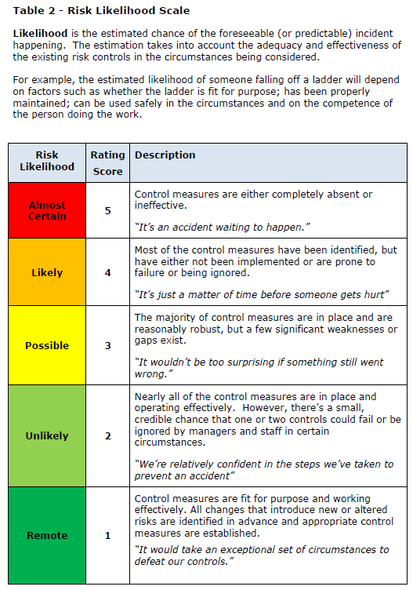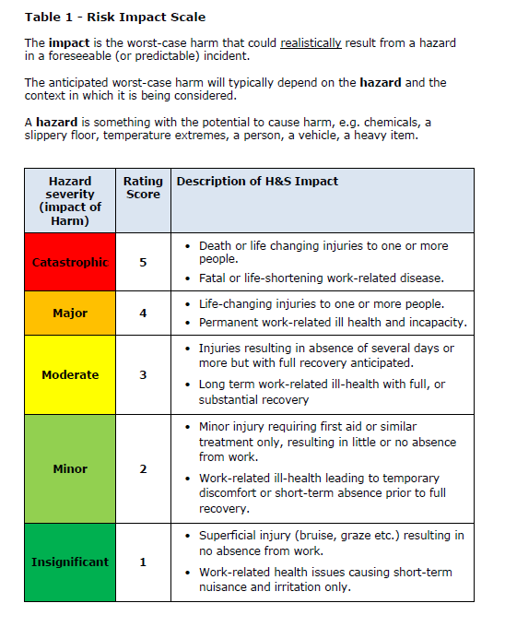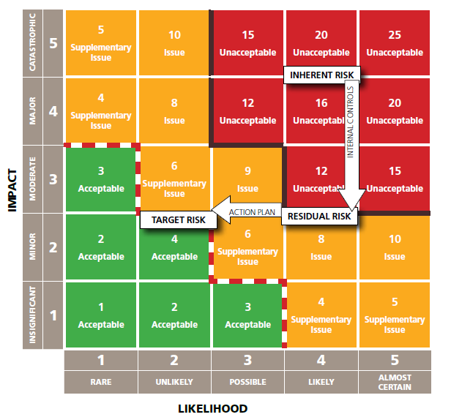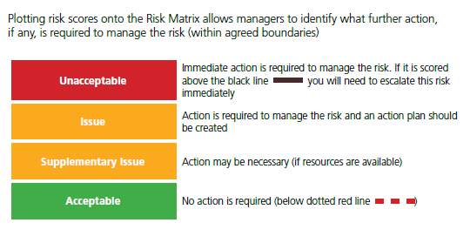

**Table 3 – Risk Matrix**