

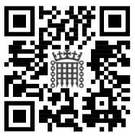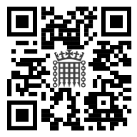

**[enter name(s) of guest(s)]**

**Search and Screening Information**

Scan me before your visit using your camera or QR code scanner app

**Event Feedback**

Scan me after

your event using your camera or QR code scanner app

RSVP by [enter date] | [enter contact name] | +44 (0)00 0000 0000 | [enter contact email address]

Entrance via [Cromwell Green/Portcullis House]

Allow at least **30** minutes for search and screening

No admittance without invitation

Smoking/e-cigarettes not permitted

No parking facilities available

Guests advised to bring personal photo ID

**[enter name of MP/Peer]**

on behalf of [enter name of organisation]

requests the pleasure of the company of

................................................................................................

for (a) / at (a) [enter event type – e.g. reception and dinner]

in [enter venue name], House of Commons

on [enter date of event] from / at [enter start time]

Address: UK Parliament, Westminster, London SW1A 0AA

Average queue time: approx. **30** minutes | Sitting Monday, Tuesday, and Wednesday afternoons: approx. **45** minutes

Please note, if your event is taking place during Prime Minister’s Questions at Wednesday lunchtime, visitors will be subject to a more thorough search by UK Parliament Security at public entrances and we advise allowing more time for security checks.

UK Parliament’s public entrances operate: Cromwell Green – Sitting Days Monday to Thursday 8:00 AM to 10:00 PM,

Non-Sitting Days and Fridays 8:00 AM to 8:00 PM, Saturdays 8:30 AM to 8:00 PM;

Portcullis House – Sitting Days Monday to Thursday 8:00 AM – 10:00 PM, Non-Sitting Days and Fridays 8:00 AM – 6:30 PM.

**Visitors will not be admitted to UK Parliament outside of the timings disclosed.**