**Inclusion and Diversity Strategy (Plan) for the House of Commons and Parliamentary Digital Service**

Easy Read Version

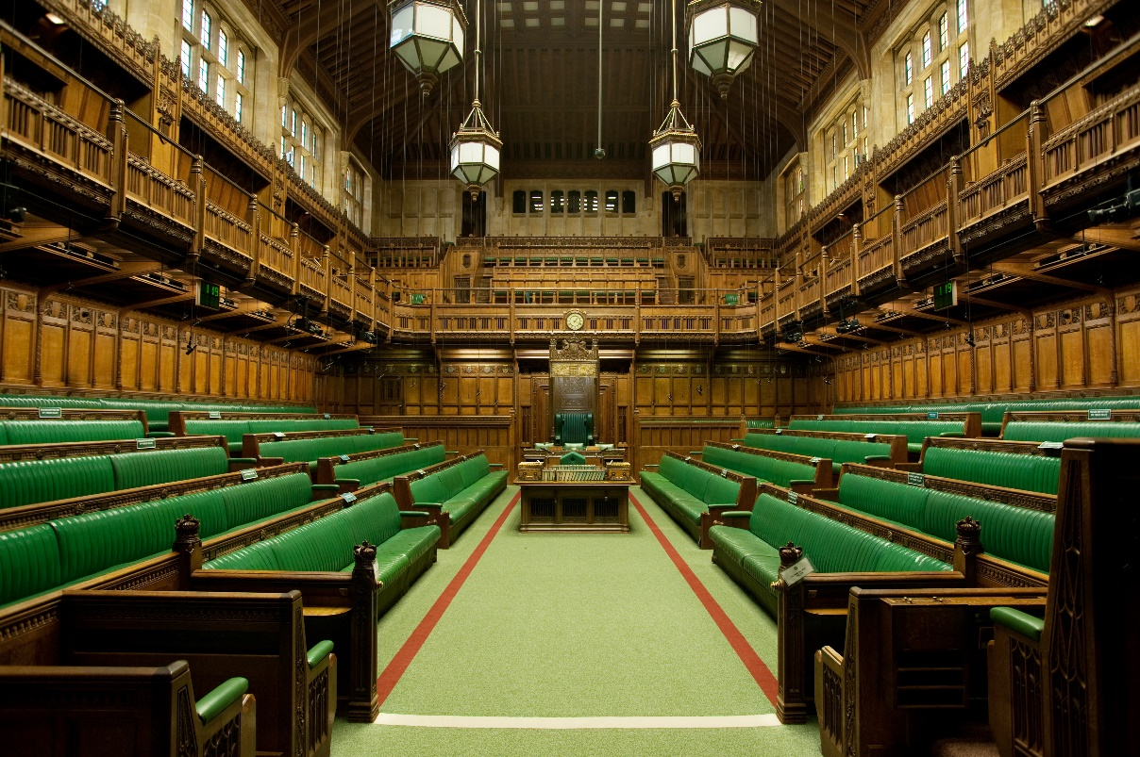

©UK Parliament – picture taken by Jessica Taylor



This document tells you what the plans are to make **the House of Commons and Parliamentary Digital Service** better for everyone. It will help people who do not feel **included**.



The plan starts in 2023.

The plan ends in 2027.



Lots of different people work at the **House of Commons** and **Parliamentary Digital Service**.





We asked them how they felt about working here.







They told us about three problems. The problems were about not feeling **included**.



The first problem:

**Black, Asian and minority ethnic** **people** are often in lower-paid jobs.



This is because more **Black, Asian and minority ethnic** **people** have lower paid jobs. For example, Cashier.



The plan will help **Black, Asian and minority ethnic** **people** get higher paid jobs. For example, Director.

How will we make this better?

* We will make processes for getting a job fairer.
* We will give learning opportunities.
* We will set goals for how many **Black, Asian and minority ethnic people** are in higher paid jobs.

?



The second problem:

Some disabled people find it hard to work here.

How will we make this better?

* We will go around our buildings and find out what could be a problem for disabled people.
* A new team will make our **technology** easier to use.
* We will help managers and teams understand disability.
* We will give information in helpful ways, like Easy Read.

?



The third problem:

**The House of Commons** and **Parliamentary Digital Service** are not as **inclusive** as we would like them to be.

How will we make this better?

* We will help **people who always have to work on the estate** to learn and engage more.
* We will help people work in different places and in different ways.
* We will help managers learn about **inclusion** and our Behaviour Code. We will give them goals.
* We will make sure the **Independent Complaints and Grievance Scheme** works well.
* We will act on **sexual misconduct**.

?